World Heritage Sites on Wikipedia: Controversies in a Context of Constrained Agency for Cultural Heritage Activism

Ben Marwick

Prema Smith

08 June, 2020

UNESCO World Heritage sites are places of outstanding significance, and often key sources of information that influence how people interact with the past today. The process of inscription on the UNESCO list is complicated and intersects with political and commercial controversies. But how well are these controversies known to the public? Wikipedia pages on these sites offer a unique dataset for insights into public understanding of heritage controversies. The unique technicity of Wikipedia, with its bot ecosystem and editing mechanics, shapes how knowledge about cultural heritage is constructed, and how controversies are negotiated and communicated. In this article we investigate the patterns of production, consumption and spatial and temporal distributions of Wikipedia pages for World Heritage cultural sites. We find that Wikipedia provides a distinctive context for investigating how people experience and relate to the past in the present. The agency of participants is highly constrained, but distinctive, behind-the-scenes expressions of cultural heritage activism are evident. Concerns about state-like actors, violence and destruction, deal-making, etc. in the World Heritage inscription process are poorly represented on Wikipedia’s World Heritage pages, instead hyper-local, and process issues dominate controversies on Wikipedia. We will consider how this kind of research, drawing on big data and data science methods, adds new dimensions to the debate on heritage controversies, especially its unique contributions, and also its limitations.

# Introduction

Heritage is the processes and outcomes of people engaging with elements of the past – material and immaterial – and attributing social and cultural meanings to them in the present (Smith 2006; Harrison 2013). These are important to understand because they shape peoples’ identities and influence how they think and behave towards other people. Digital heritage are these engagements that are enabled by the Internet (Bonacchi and Krzyzanska, 2019), leaving traces that can be identified and quantified using data science methods. Digital heritage studies represent a major turn from traditional heritage studies, characterized by post-modernism (Kristiansen, 2014), critical theory, and qualitative methods, towards novel ontologies, data-intensive ethnographies, and a new role for heritage scholars as data scientists. Bonacchi et al. (2019; 2018) have sketched out the new digital heritage research program with their combination of data-intensive and qualitative investigations of 1.4m Facebook posts in Brexit-related community groups. They found recurring parallels – both pro- and anti-Brexit – made by Facebook users between the European Union, the Roman Empire and “barbarians” as they use heritage to support their political activism. They demonstrate the potential for understanding public perceptions and experiences of the past in contemporary society using big data obtained from social media. In this paper we extend the digital heritage research program in two important new directions. First, we introduce Wikipedia as an example of an online peer production community where people engage with elements of the past in measurable ways. Second, present a case study using data science methods to investigate the ways people create and consume Wikipedia articles on cultural sites inscribed on the UNESCO World Heritage List (hereafter CS-WHL).

While social media is a vast and diverse online space that we are only just beginning to explore how people engage with the past, there are other contexts of online interactions where heritage is practiced in distinctive, if poorly understood, ways. We can contrast social media, with its fundamental elements of identity, conversations, sharing, presence, relationships, reputation, and groups (Kietzmann et al., 2011), with peer production communities, where online users participate in the collaborative, asynchronous creation, sharing, promoting, and classification of content in highly structured and goal-directed ways (Wilkinson, 2008). Online peer production communities are comparable to more traditions kinds of voluntary associations where groups set and execute goals, with explicitly democratic organizational ideals. While the ideals of many online peer production communities emphasize non-hierarchical and non-bureaucratic organization, analysis of large amounts of user activity indicates that most of these communities are actually undemocratic and noninclusive, functioning as entrenched oligarchies (Shaw and Hill, 2014). This emphasis on governance and management of collective action is a key detail that distinguishes online communities on social media from online communities on peer production projects. It follows that user interactions in the process of generating context in online peer production communities includes technological and social mechanisms that enact the community’s governance policies, for example, limiting a user’s activity according to their status in the community’s hierarchy, or managing conflict with highly structured procedures. These distinctive organizational and technical qualities of online peer production communities make them an intriguing novel context of heritage production to study digital traces of human activity resulting from engagement with the past

## Wikipedia as a Context of Heritage Production

Here we present a study of how people engage with elements of the past in one of the largest and long-lived online peer production communities, Wikipedia. Originating in 2001, this is a highly influential and well-known online encyclopedia, currently with 11 billion page views per month (<https://stats.wikimedia.org/#/en.wikipedia.org>), that anyone can edit. Although anyone can edit, most internet users do not, and the characteristics of people who do edit are important to understand to identify biases in the encyclopedia’s content. In a survey of 1,512 American adults, Shaw and Hargittai (2018) found that majority of internet users (96.5%) had heard of Wikipedia, and 82.5% of those said that they had ever visited the site. Just over two thirds (67.3%) knew that Wikipedia can be edited, but only 8.2% of the full sample had ever edited any page. Factors that strongly predict if a user has ever edited Wikipedia include their gender (male), age (younger), education level (has BA), Internet use frequency (higher) and Internet use skills (higher). Hill and Shaw (2013) a similarly found that among U.S. adult contributors to the English-language edition of Wikipedia, at least 75% are male. While gender disparities have been documented throughout Wikipedia (Adams and Brückner, 2015; Ford and Wajcman, 2017), there are also geographical disparities. Johnson et al. (2016) examined 218,709 English geotagged articles about places in the contiguous United States and 46,124 Chinese geotagged articles about places in China to investigate differences in articles about urban and rural places. They found that articles about rural areas have systematically lower quality, are less likely to have been produced by contributors who focus on the local area, and are more likely to have been generated by bots (automated software agents). These studies indicate that inequalities on a range of variables mean that participation in online peer production communities often exacerbates existing patterns of social exclusion. Graham et al. (2014) examined the global distribution of 3.4 million geotagged Wikipedia articles and find a pattern of places in the Global North being represented in local languages, while articles about places in the Global South are largely being written by others. They find that most of the variation in the spatial distribution of geotagged articles could be explained by three variables: the population of the country, the number of fixed broadband connections, and the number of edits emanating from that country.

An additional consideration for understanding participation in online peer production communities are the technical schemas of the software that Wikipedia runs on, MediaWiki. This is a complex toolkit that enables participation in Wikipedia in highly structured ways. On one hand, these structured behaviours produce structured datasets that are well suited to data science methods for efficient computational analysis of large numbers Wikipedia articles. On the other hand, they constrain and limit the agency of the user, canalizing their behaviour into a small number of possible actions and acceptable modes of discourse and engagement with other users (Iba et al., 2010). While Wikipedia has elements that are ubiquitous on the Internet, such as links on articles that take the user to other articles or other pages on the Internet, it also has several less common elements that contribute to its unique technicity, resulting in very specific types of relationships between human users and the technical elements of the Wikipedia project (Niederer and Van Dijck, 2010; Weltevrede and Borra, 2016). For example, every edit to an article is tracked in a publicly accessible version control system attached to that article. This exposes the article creation process in highly granular detail; for any given article, we can see how many editors contributed, the size of their edits and their distribution over time, among other things (Priedhorsky et al., 2007). Wikipedia has a special category of edit called the ‘revert’ which allows a user to restore an article to an earlier state to remove recent vandalism (such as the addition of irrelevant or offensive material). This special revert action, combined with a ‘talk’ page attached to each encyclopedia article for threaded discussion among editors, allows us to detect and study the dynamics of conflicts arising from the creation and editing of articles (Suh et al., 2007). While articles themselves must be written to conform to the fundamental Wikipedia policy of NPOV (Neutral Point Of View), the talk page is where different views are expressed and negotiated among editors in detail. Taken together, a high proportion of ‘revert’ type edits, and a high word count on the talk page can indicate the controversiality of an article (Yasseri et al., 2012).

Table 1: Summary of Wikipedia bot types and functions, from Zheng et al. (2019)

|  |  |  |
| --- | --- | --- |
| Role | Function | Example |
| Generator | Generate article pages based on predefined templates. | Rambot, RussBot |
| Fixer | Fix errors in article pages in order to keep the information neat and correct. | CmdrObot, Yobot |
| Connector | Connect Wikipedia with other sites and databases | KasparBot |
| Tagger | Tag articles with different templates and categories | AnomieBot, Smackbot, Cydebot |
| Clerk | A variety of tasks including updating statistical information, documenting user status, updating maintenance pages | AnomieBot, Smackbot |
| Archiver | Archive closed discussions and maintain the archived content by assigning an index and sorting them alphabetically | AnomieBot, Cyberbot_I |
| Protector | Detect and regulate destructive behaviors | ClueBot NG |
| Advisor | Provide editors with suggestions about articles that they might want to contribute to. | SuggestBot |
| Notifier | Deliver messages to editors. | NoomBot |

In addition to the human users and the technological system that enables and constrains their activities on Wikipedia, there is an important third element of the ecosystem that contributes to Wikipedia’s uniqueness: the bots. Wikipedia bots are computer scripts that automatically handle repetitive and mundane tasks to develop, improve, and maintain the encyclopedia. While bots are not unique to Wikipedia, they are important contributors, responsible for a large proportion of edits, and shape the human experience in significant ways (Geiger, 2014, 2009; Niederer and Van Dijck, 2010). They also evolve and autonomously engage in complex interactions with other bots to modify the encyclopedia (Geiger and Halfaker, 2017; Tsvetkova et al., 2017). Zheng et al. (2019) studied all 1,601 bots that were registered at the time of their study, and classified them into 9 bot roles and 25 associated bot functions. Table 1 shows the bots that were identified in our study and their categories and functions according to Zheng et al. (2019).

## UNESCO World Heritage Cultural Sites as foci of Conflict

We investigate how the unique technicity of Wikipedia shapes interactions between people and the past with a case study on the processes of constructing knowledge about cultural sites inscribed on the WHL. We chose the CS-WHL as a bounded set of cultural heritage elements with several characteristics that make it of general interest. It has a global geographic distribution, broad public interest at local and international scales, in both online and face-to-face communities; a wide temporal distribution in both the age of the cultural sites, the ages of inscription on the WHL, and the ages of their appearance on Wikipedia; and finally many CS-WHL have a high intensity of cultural and political discussions that surround events affecting these sites, such as their inscription on the WHL. These qualities make it an ideal data set as an entry point for case studies of digital heritage in online peer production communities, where activities are typically goal-driven (e.g. ‘write quality articles’) compared to social media activity where user activities are more often event-driven (e.g. ‘share reactions to Brexit’).

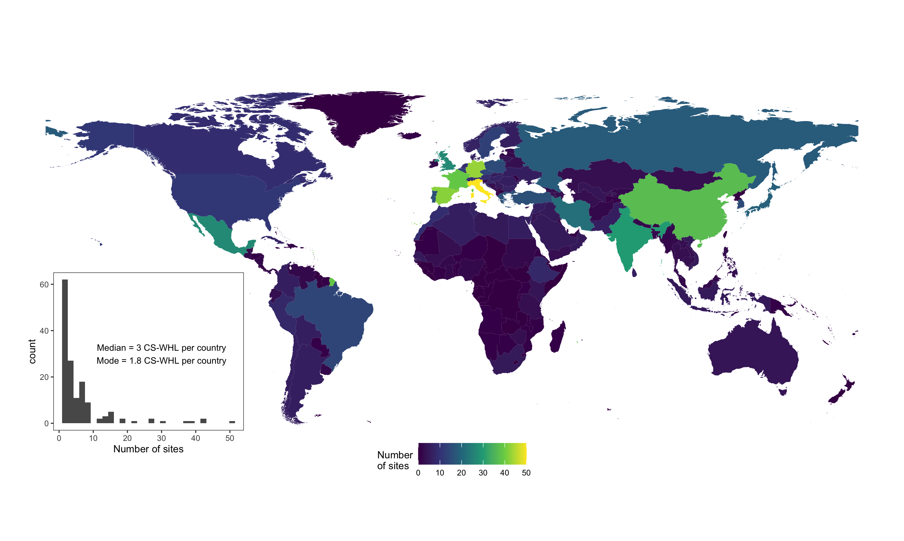

Figure 1: Cultural Sites on the UNESCO World Heritage List. Countried coloured black currently have no listed cultural sites. Inset shows the distribution of sites per country. Map data from naturalearthdata.com

UNESCO was established in 1945, shortly after the end of the Second World War, for the purpose of helping to rebuild after the war, and preserve peace by promoting the international exchange of ideas. In 1975 the UNESCO-drafted “Convention Concerning the Protection of the World Cultural and Natural Heritage” came into force and established the World Heritage List (WHL) to protect natural and cultural sites and landscapes around the world that have outstanding universal value. Currently there are 869 cultural properties on the UNESCO WHL, with the first sites inscribed in 1978. On average, most countries have 2-3 sites, with most sites located in Italy and western Europe, and several countries having no sites at all, for example, several central African countries, Taiwan, and New Zealand (Figure 1).

In her institutional ethnography of UNESCO’s role in protecting world heritage, Meskell (2018) argues that the WHL is less about preserving heritage than about political and economic transactions between states and state-like actors. Sites that are listed, or candidates for listing, are often foci of disputes and negotiations about territory, sovereignty, and security, as well as international corporate activity (Meskell, 2018). This is because the process of selecting of sites to be inscribed on the WHL has become politicized and driven by countries’ political influence and national strategic interests (Bertacchini et al., 2016). For example, the members of the World Heritage Committee are mostly career diplomats rather than heritage specialists, indicating that the processes and decisions of this committee may be motivated more by political trade-offs than by heritage expertise and judgment (Von Droste, 2011).

Several CS-WHL sites are notable for the conflicts and tensions that have surrounded their inscription. The 1992 inscription of Angkor (an ancient city and empire in Cambodia, prominent during the 9th to the 15th centuries AD) was supported by exiled supporters of the genocidal Khmer Rouge regime, hoping to strengthen territorial claims (Locard, 2015). They appropriated Western discourse on national cultural heritage to argue for the safeguarding of Angkor as part of their quest for national independence and international recognition. Early in the Khmer Rouge regime Angkor was declared a symbol of enslavement by a primitive culture, but when the Khmer Rouge adopted a new rhetoric of a supposedly civilizing mission, they presented it as the site one of the great world civilizations (Falser, 2015). The 2003 inscription of Mapungubwe (the site of the first indigenous kingdom in Southern Africa, 900-1,300 AD) was preceded by a recommendation from ICOMOS (International Council on Monuments and Sites, a professional association that is a key advisory body to the World Heritage Committee) not to inscribe because of the farming and mining activity in highly sensitive areas near the site, and the unclear ownership of the mining rights at the time (Meskell, 2011). Despite this negative recommendation, geopolitical machinations within the Committee, especially by the Indian and Russian delegates, led to Mapungubwe being inscribed on the list, although without the typical prerequisites of an integrated management plan or complete buffer zone (Meskell, 2012). These examples of Angkor and Mapungubwe demonstrate the attention that the WHL inscription process can generate due to political activitsm, conflicts and intrigue.

Physical conflict at or near CS-WHL are also major events that galvanise public interest in these locations. World Heritage sites in Palestine, Mali, Syria, Congo and Cambodia have recently been sites of violence, in many cases the violence is specifically linked to their potential WHL nomination, listing or management. In 1998 anti-government and mostly Hindu Tamil groups bombed the holy Buddhist site of the Temple of the Tooth at the WHL site of Kandy (the last capital of the ancient kings of Sri Lanka), killing 17 people and substantially damaging the temple (Coningham and Lewer, 1999). In Mali during 2012, fighting between government and rebel groups lead to the damage and destruction of tombs at the CS-WHL sites of Gao and Timbuktu (Brioschi, 2017). The World Heritage Committee found itself powerless to intervene because of political gridlock (Meskell, 2015), and these Mali sites are currently among the 36 cultural sites on the List of World Heritage in Danger (<https://whc.unesco.org/en/danger/>). In 2015, ISIS militants destroyed the Temple of Bel in Palmyra, Syria (a CS-WML site of monumental ruins, once great city at the crossroads between east and west in the ancient world) (Gornik, 2015). Preah Vihear, inscribed in 2008, is a CS-WHL located on a long-disputed section of the Thai-Cambodia border that has been a site of both violent military clashes and international political intrigue. Although both Thailand and Cambodia supported the nomination of the site to the WHL, the Thai government objected to maps in the nomination package that showed Cambodia as the owner of disputed land next to the temple, leading to protests and military clashes (Sothirak, 2013). Meskell (2016)’s analysis of US diplomatic cables released by WikiLeaks further reveals that settlement of disputes over Preah Vihear were intricately tied to broader issues of foreign policy and US and Chinese investment, especially access to natural gas reserves in the Gulf of Thailand. For example, the cables reveal negotiations for Cambodia to retain their temple, leading to the enhancement of Thailand’s underwater assets, and the United States negotiating for extended contracts with both countries.

# Methods

Our brief review of controversial cultural sites on the WHL shows the intensity and diversity of conflicts and tensions that surround these sites. Many CS-WHL are symbols of national, cultural, political, and religious identity, and the extent of political involvement in negotiations of WHL inscriptions indicates they are of great public interest among local and diasporic communities. Our goal in this study is answer the question of how this interest is expressed within the socio-technical constraints of Wikipedia. How are conflicts over CS-WHL enacted in the canalized interactions of the world’s largest encyclopedia? We attempt to answer this question by studying all the CS-WHL that have Wikipedia articles. We surveyed the basic characteristics of content (article length, number of wikilinks out to other pages, number of citations to non-Wikipedia items), consumption (page view counts, wikilinks in from other Wikipedia pages), and production (edit counts, edit densities, edit sizes, number of unique editors per article, talk page length, talk page topics). There are great many additional metrics available for Wikipedia articles, an we have limited ourselves to the most basic for this initial investigation. By comparing these basic characteristics of Wikipedia articles about CS-WHL to 10,000 random Wikipedia articles we will answer the question: how does engagement with the past compare via CS-WHL on Wikipedia compare to engagement with other topics? Do Wikipedia articles about controversial CS-WHL sites, such as those discussed above, get more attention than random Wikipedia articles? Can we detect conflict in the edit histories, bot activity, and talk pages for Wikipedia articles about CS-WHL sites, and how does this conflict relate to the types of controversies noted above?

The highly detailed edit histories that Wikipedia keeps for every article allow us to further investigate spatial and temporal questions relating to engagement with the past and conflicts surrounding CS-WHL sites. For example, when an article is edited by a user who does not have a Wikipedia user account (or is not logged into their account), their edit is identified by that person’s IP address. This IP address can be used to geo-locate the user to the city they were in when the made the edit. We geo-located all edits with IP addresses for all Wikipedia articles CS-WHL sites to determine the country of origin of those edits. This helps us to answer the question: are the editors of articles about CS-WHL located near the sites they edit, indicating local community interest in the online representation of their heritage? Or are editors located in other countries, implying a digital colonialism of world heritage information on Wikipedia where one community’s heritage is interpreted and communicated by another? The time and date stamps attached to every edit on every article allows us to investigate temporal patterns of activity on CS-WHL Wikipedia articles. Analyses of these data help us to answer the question: is Wikipedia editing activity correlated with events outside of Wikipedia relating to the CS-WHL sites, such as conflict events, or their inscription on the WHL?

We obtained data about Wikipedia articles by scraping the HTML pages with the rvest package for R (Wickham, 2019). We used the SelectorGadget (Cantino and Maxwell, 2017) extension for the Chrome web browser to identify specific elements of interest, or nodes, on the HTML pages, and wrote custom R functions to extract data from these nodes. Our entry points were the Wikipedia articles that are lists of World Heritage regions in major geographical regions of the globe. We found fifteen of these, and scraped the CS-WHL site names from the tables on these pages, and followed the links to scrape the article text, edit history and talk page text for each CS-WHL site included on those tables. A small number of CS-WHL sites have Wikipedia articles that are not included on these tables, we did not include these in our sample. We chose this approach because the Wikipedia article titles for CS-WHL sites often differ from the official site name on the UNESCO list, making manual look-ups very inefficient.

The highly structured nature of most Wikipedia pages afforded us much efficiency during data collection, however, a not insignificant number of pages had minor irregularities, for example, exotic table formatting or minor deviations from widely used templates, that necessitated more complex programming. An especially challenging issue was minor irregularities in spelling place names, for example, “Saint Kitts and Nevis” and “St. Kitts and Nevis”, which can confound programmatic joining and summarizing of data by failing to recognize as the same place and leading to under-counting. We attempted to correct these manually in our code. Another challenge was in the formatting of tables, for example a merged cell in a table introduced an irregularity that made parsing and scraping complicated and fragile. We collected data during May 2019, and due to the dynamic nature of Wikipedia, it is highly likely that articles in our study have subtly changed since our data collection as users and bots continue their activity. It is unlikely that articles in our sample have been deleted from Wikipedia since our data collection, because of the high notability of CS-WHL, but it is possible that new articles have since appeared about sites that were not represented on Wikipedia since we collected the data. Our original scraping code may no longer work as the tables on Wikipedia articles continue to be modified.

# Reproducibility and Open Source Materials for This Study

To enable reuse of our materials and improve reproducibility and transparency (Marwick, 2017), we include the entire R code (R Core Team, 2020) used for all the analysis and visualizations contained in this article in our compendium at <http://doi.org/10.17605/OSF.IO/AY27G>. Also in this version-controlled compendium are the raw data for all the results reported here. All of the figures and quantitative results presented here can be independently reproduced with the code and data in this repository. In our compendium our code is released under the MIT license, our data as CC-0, and our figures as CC-BY, to enable maximum reuse (for more details, see Marwick et al. (2018)).

# Results

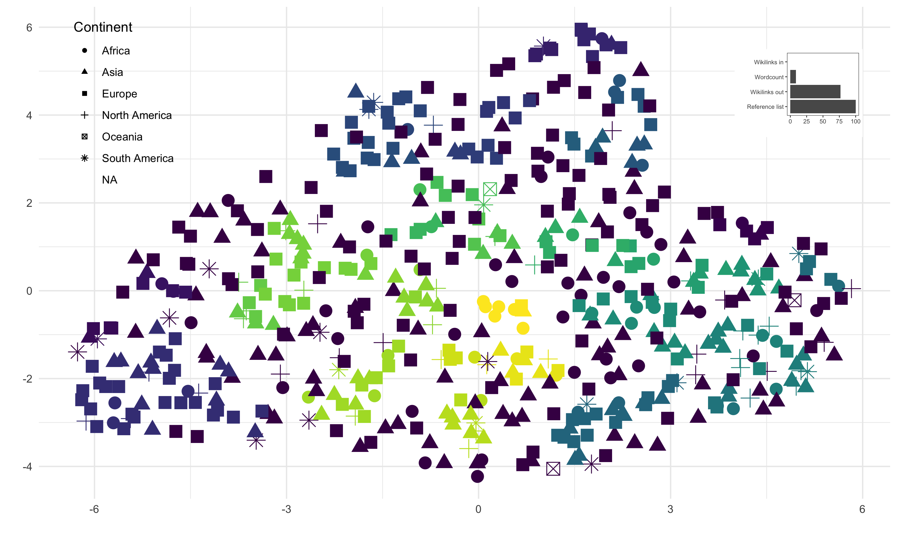

Figure 2: Results of UMAP and HDBSCAN analysis to identify clusters of articles. Point colour indicates cluster membership. Inset plot shows variable loadings to show variables most influential on cluster membership

Of the 869 cultural sites on the World Heritage List at the time of writing, we found Wikipedia articles for 582. To characterize the overall variability of article according to the basic characteristics described above, we applied a Uniform Manifold Approximation and Projection (UMAP) to reduce the dimensionality of our data (McInnes et al., 2018). After a two-dimensional projection was obtained, we used Hierarchical Density-Based Spatial Clustering of Applications with Noise (HDBSCAN) to identify clusters (Campello et al., 2013), and Random Forests to identify variable loadings (Breiman, 2001) so we could determine which of the basic characteristics were most important in driving variability between the articles. This revealed 33 clusters, with the most important variables for determining cluster membership being the number of items in the reference list at the end of the article, the number of words in the article, and the number of Wikilinks out from the target article to other Wikipedia articles. That said, 226 (40%) articles were not assigned to a cluster by the HDBSCAN algorithm, indicating that the basic characteristics of CS-WHL articles do not partition the articles in highly structured and discrete groups.

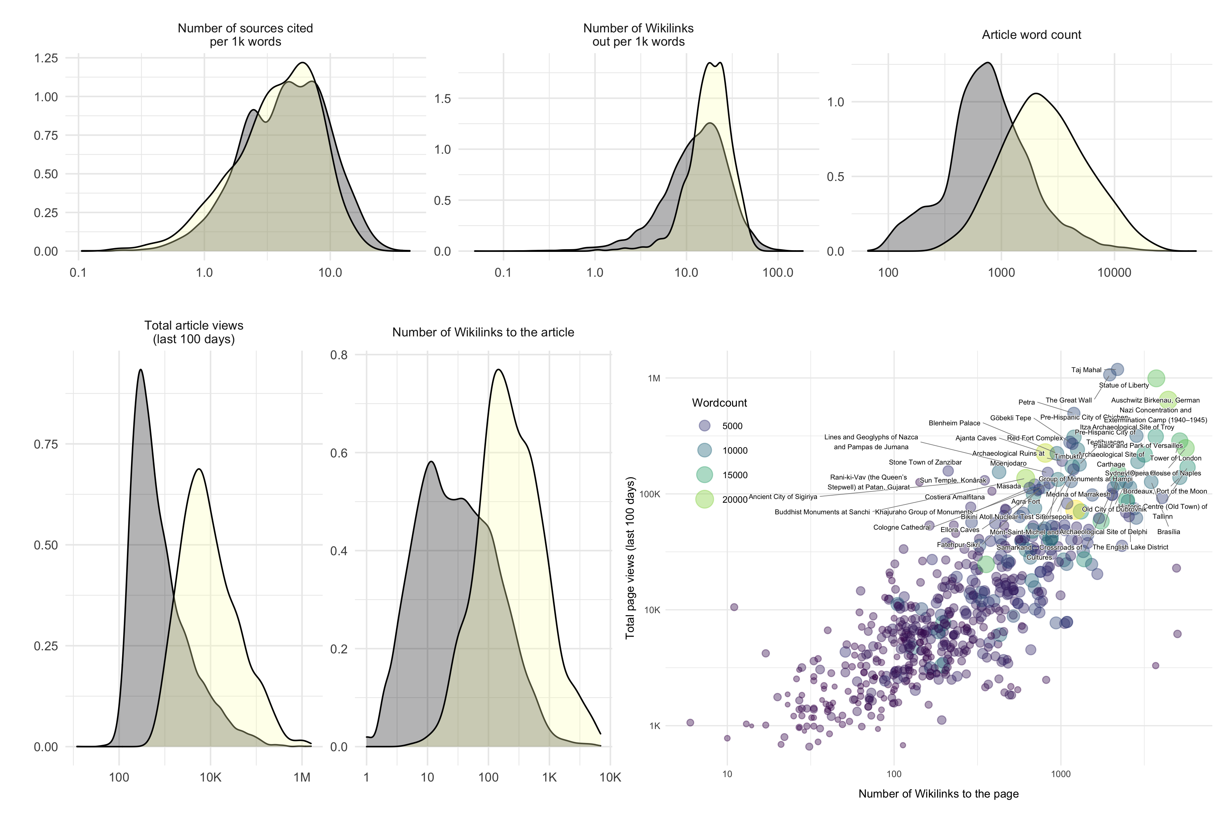

Figure 3: Content and consumption of Wikipedia articles about CS-WHL. The top row of density plots show the distributions of basic content characteristics of Wikipedia articles about CS-WHL (yellow) compared to 10,000 random Wikipedia articles (grey). The density plots on the lower left show basic characterstics of consumption. The lower right shows a scatterplot of consumption metrics for Wikipedia articles about CS-WHL and labels on the most intensively consumed articles

As a group, the basic details of content for Wikipedia articles for CS-WHL differ little from a sample of 10,000 random Wikipedia articles (Figure 3). The scholarly nature of the articles, measured by the number of sources cited in the reference list per thousand words in the article body, is similar for CS-WHL articles and random articles. The number of Wikilinks out from the target article to other Wikipedia articles is also similar for CS-WHL articles and random articles. However, the total number of words in a CS-WHL article is typically much higher than a random article.

The basic metrics of consumption of CS-WHL articles show substantial differences from our sample of random articles (Figure 3). We measure consumption by counting the total number of views of the article over the 100 days prior to our data collection date, and the the number of Wikilinks from other articles into the target article. Wikipedia article view counts are popular widely-used measures of cultural interest or salience (Cao et al., 2020; McIver and Brownstein, 2014; Roll et al., 2016). Wikilinks from other articles are a measure of the centrality of an article, if many other articles link to it, then the article is well-integrated into the encyclopedia and viewed as important for supporting information presented in other articles. CS-WHL articles are typically viewed far more frequently than other Wikipedia articles, reflecting high consumption by internet users generally. They are also much more often linked to by other Wikipedia articles than our random sample of other articles, indicating consumption by other Wikipedia articles and Wikipedia users in their editing work (Figure 3). This indicates that consumption of CS-WHL articles is generally very high. But is this attention evenly distributed across all CS-WHL articles?

The scatterplot on the lower right of Figure 3 shows the values of inward Wikilinks, article views and article word count for all CS-WHL articles. The labeled points in the upper right quadrant are the articles that receive most of the attention. Of the CS-WHL notable for conflict discussed above, only Timbuktu is visible among these highly popular articles. It is also the only site on the List of World Heritage in Danger that is among these highly popular articles. We reviewed the talk page for the Timbuktu article to determine if the attention received by the article might relate to the issues leading to armed conflict at the site. Of the 6162 words on the talk page, only 168 are on the topic of conflict and destruction, with the editors discussing how to describe the scale of the damage to the temples. The majority of talk page content is about filling in missing detail, suggestions for or notifications of minor corrections. This is also the case for the talk page for Auschwitz, another very popular CS-WHL article. Although Wikipedia articles on this site in other languages have different points of emphasis (Wolniewicz-Slomka, 2016), the discussion among editors is generally technical and precise, and provocative comments usually ignored rather than directly disputed. This can be contrasted with the talk page for the Holocaust, where Pfanzelter (2015) found abundant evidence of conflict among editors.

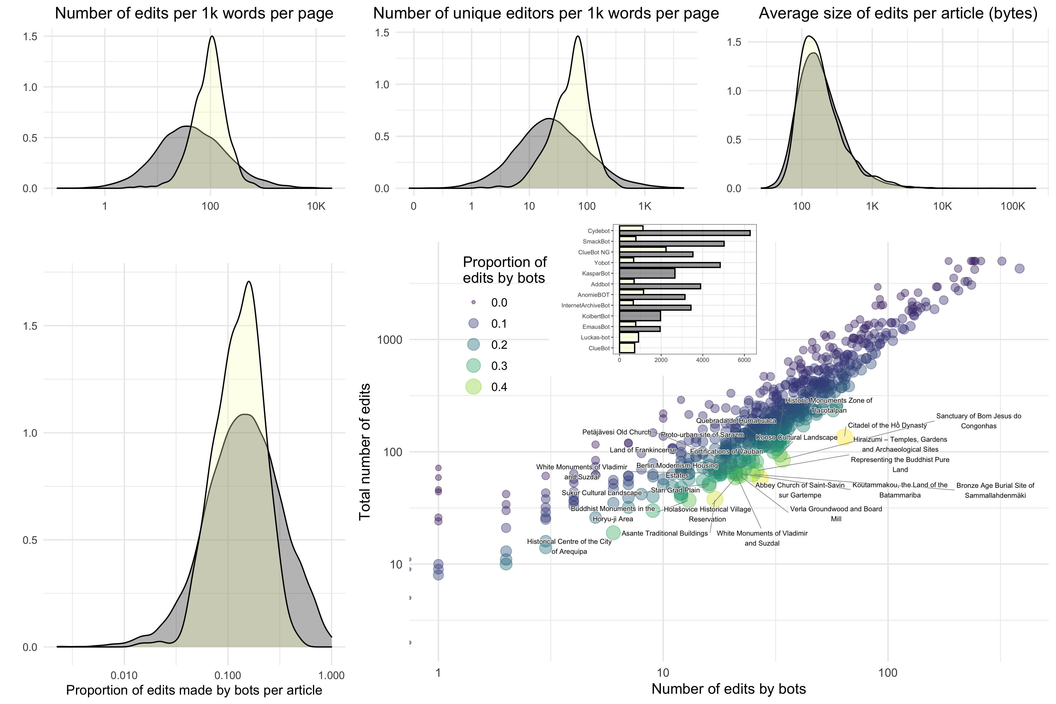

Figure 4: Production of Wikipedia articles about CS-WHL. The top row of density plots show the distributions of basic article production characteristics of Wikipedia articles about CS-WHL (yellow) compared to 10,000 random Wikipedia articles (grey). The density plots on the lower left show the distribution of edits made by bots. The lower right shows a scatterplot of production-by-bot metrics for Wikipedia articles about CS-WHL and includes labels on the articles where bots were responsible for >30% of edits. Inset on the scatterplot shows the number of edits for the top ten bots in our sample.

Basic variables related to the production of Wikipedia articles on CS-WHL differ in key ways from other articles (Figure 4). The number of edits per thousand words, or edit density, and the number of unique editors per thousand words, or editor density, are substantially higher for CS-WHL articles. CS-WHL articles are intensively word-smithed by a more diverse community of editors than usual. The absolute size of edits (i.e. additions or removals of text) is about the same for CS-WHL articles as other articles. The involvement of bots in producing CS-WHL articles is also about the same as for other articles. Bot activity is most intense on shorter, low-profile CS-WHL articles, in Figure 4 the labeled points are sites where bots have done >30% of edits. Most of these bot edits are in the fixer, tagger, connector, and clerk roles. None of these articles with intensive bot activity are CS-WHL sites of conflict or on the List of World Heritage in Danger. The most active bot on CS-WHL articles is Cluebot NG (vandalism detection and reverting), compared to Cydebot (automatic implementation of category deletions) for the random articles. The AnomieBOT is very active on CS-WHL articles compared to random articles, this bot performs clerical duties in an article’s reference list.

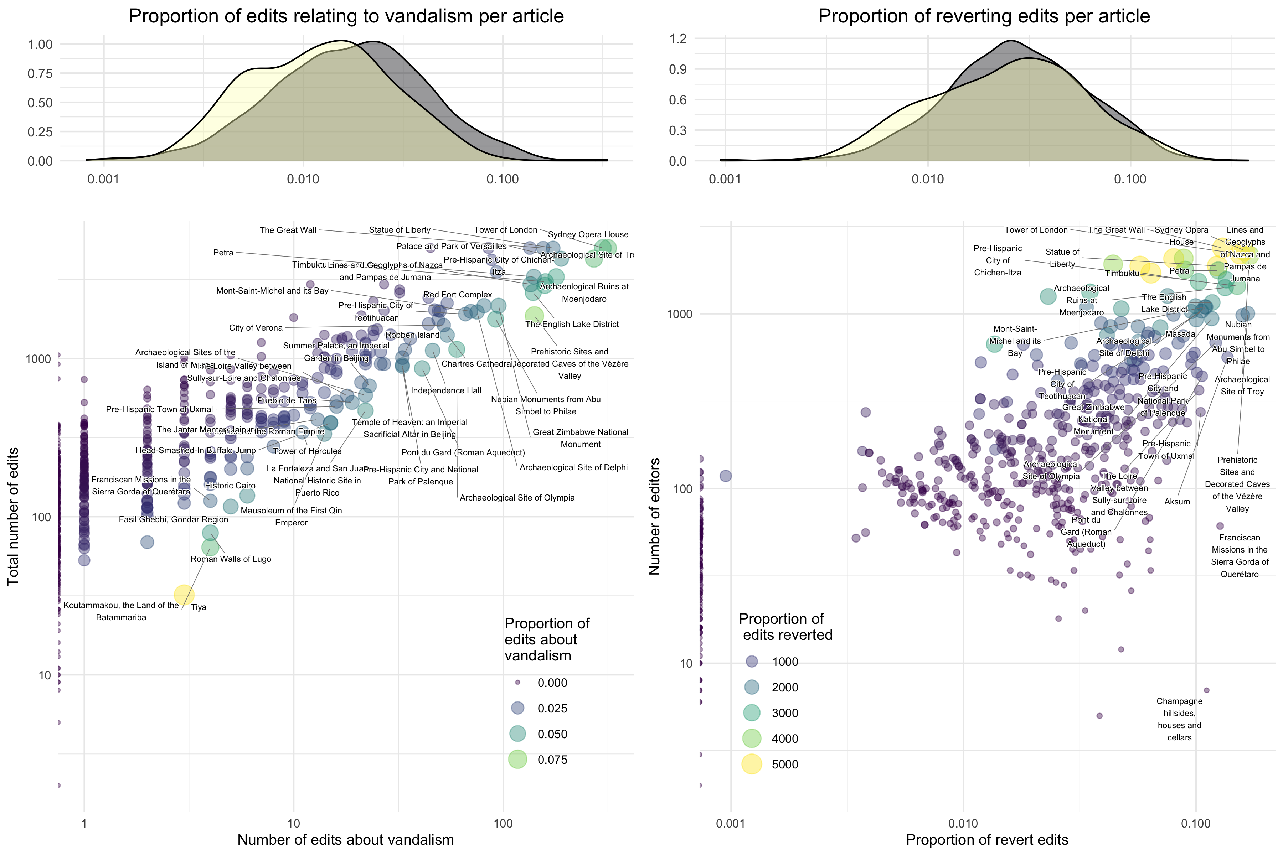

Figure 5: Reverted edits and edits about vandalism in Wikipedia articles about CS-WHL. The top row of density plots show the distributions of proportions of edits relating to vandalism, and the proportion of revert edits in Wikipedia articles about CS-WHL (yellow) compared to 10,000 random Wikipedia articles (grey). The scatterplots below show reverted edits and edits about vandalism metrics for Wikipedia articles about CS-WHL, and includes labels on the articles with high proportions of these types of edits.

For the special ‘revert’ edit type, we see that the proportion of all edits per CS-WHL articles is similar to other articles, but has a left-skewed distribution indicating a higher number of articles that have very few revert edits (Figure 5). We also identified edits with the string ‘vandal’ in the edit summary as a similar type of edit to the revert edit, e.g. “Edits by 72.49.241.71 identified as vandalism”. CS-WHL articles generally have fewer edits about vandalism than our random sample. The shape of the distribution of edits about vandalism has a smaller second mode to the left of the peak, indicating that a large number of CS-WHL articles have very few edits about vandalism (Figure 5). Among the CS-WHL articles that have high proportions of reverts and edits about vandalism are highly iconic sites in the Western canon of culture history, e.g. the Sydney Opera House, the Tower of London, and the Statue of Liberty (cf. Harrison, 2013). In reviewing a sample of several hundred reverted edits for each of these, we found that nearly all of them are undoing the addition of short strings of text (e.g. profanities, spam, nonsense). Much of this vandalism is playful, in the spirit of “‘I am’, a statement that one is present and alive”, as Baker (2003) described historical graffiti on the Reichstag in Germany by Russian soldiers in WW2. Once again, of the CS-WHL sites with a history of conflict or on the in-danger list, only Timbuktu appears here as having high proportions of revert and vandalism-reversing edits.

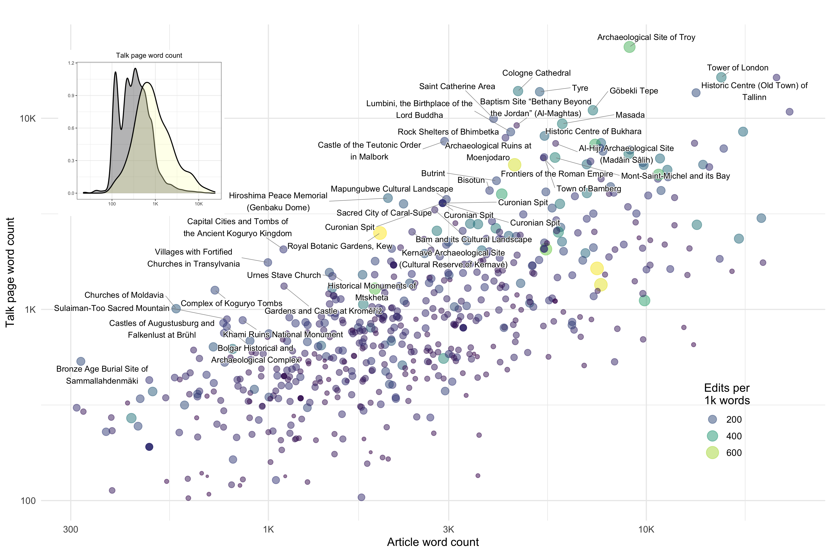

Figure 6: Scatterplot showing the length of each CS-WHL article and the length of each article’s talk page. Labelled points are articles where the talk page is longer than the article. Inset shows the distribution of talk page lengths for CS-WHL articles and 10,000 random articles

Talk pages are another location where we may see conflicts and debates unfold on Wikipedia. Wikipedia talk pages are a popular subject of investigations to understand the collaborative generation of knowledge and online conflict management (Ho-Dac et al., 2017, 2016; Kittur et al., 2007; Schneider et al., 2012). The length of an article’s talk page is correlated with the controversality of the article, and thus an effective simple proxy for conflict (Yasseri et al., 2012). We counted the words on all talk pages of the CS-WHL articles to identify conflict (Figure 6). Talk pages for CS-WHL articles tend to be much longer than other articles, which we expect due to the CS-WHL articles themselves being generally longer than other articles. However, the distribution of talk page lengths for CS-WHL articles has a long right tail, indicating that a higher number of articles have very long talk pages, compared to other articles. While it is true that some of these articles with long talk pages, such as Cologne Cathedral and Troy, have clear evidence of conflict among the editors, close reading of the discussions reveals that the debates are dominated by technical issues. For example, the Cologne Cathedral talk page includes some debate about the correct calculation of the interior volume of the structure, and on the Troy talk page there is a heated comments by one editor about another editor removing of some of their text containing unsourced claims and unencyclopedic writing style.

Only one of the controversial sites discussed above is in the group of articles where the talk page is longer than the article itself, and none of the site on the UNESCO heritage in danger list are in this group. The talk page for Mapungubwe is lengthy with expressions of concern about the accuracy of information in the article. In particular, editors were concerned about the depiction of Indigenous people, especially the degree to which early European colonists were aware of Indigenous communities, and the correct cultural affiliation of the Indigenous groups that originally occupied the site. These issues closely echo the themes identified by Meskell (2011) in her analysis of the WHC process. Although not notable for the length of its talk page, the discussions among editors of the article about Preah Vihear Temple include a strongly worded disagreement among seven editors about the legitimacy of the ownership claims by Thailand and Cambodia of the territory that includes the temple. The debate among Wikipedia editors mirrors very closely the political tensions surrounding the nomination of Preah Vihear. The talk page also has a much longer argument, mostly between two editors, about whether or not the Thai name of the site should be included in the text of the article. This debate also recapitulates issues of which country has the stronger claim for ownership of the temple. Amid accusations of nationalism among the editors, one of them asks “Can we put aside politics and be more collaborative on the encyclopedia project?” and appeals to Wikipedia policies ‘Third opinion’ and ‘Dispute resolution’ to diffuse the tensions and refocus attention on the common goal. Beyond these two pages we found that the majority of content on CS-WHL article talk pages is about highly local topics, mostly article administration, editing processes, and quality control.

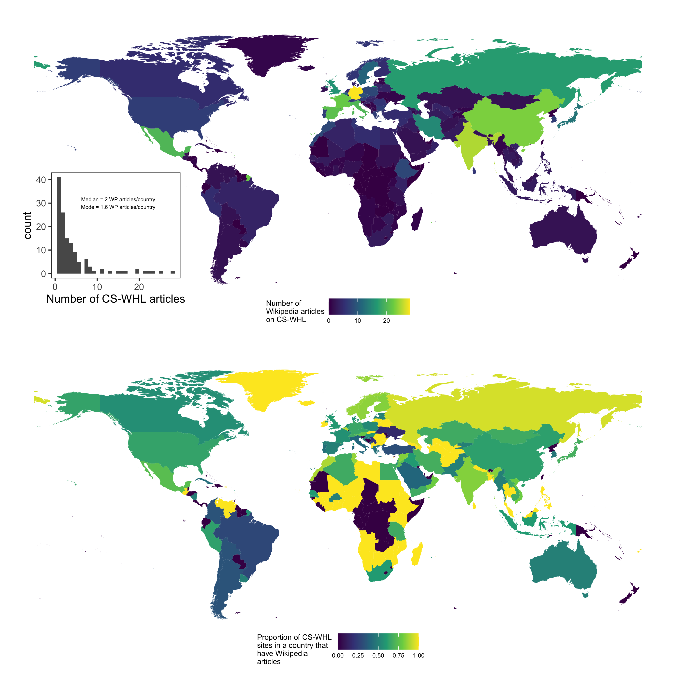

Figure 7: Wikipedia articles for Cultural Sites on the UNESCO World Heritage List. Upper panel shows the total number of Wikipedia articles for CS-WHL sites per country. Lower panel is the proportion of all CS-WHL sites that have Wikipedia articles per country. Inset shows the distribution of numbers of CS-WHL articles per country. Map data from naturalearthdata.com

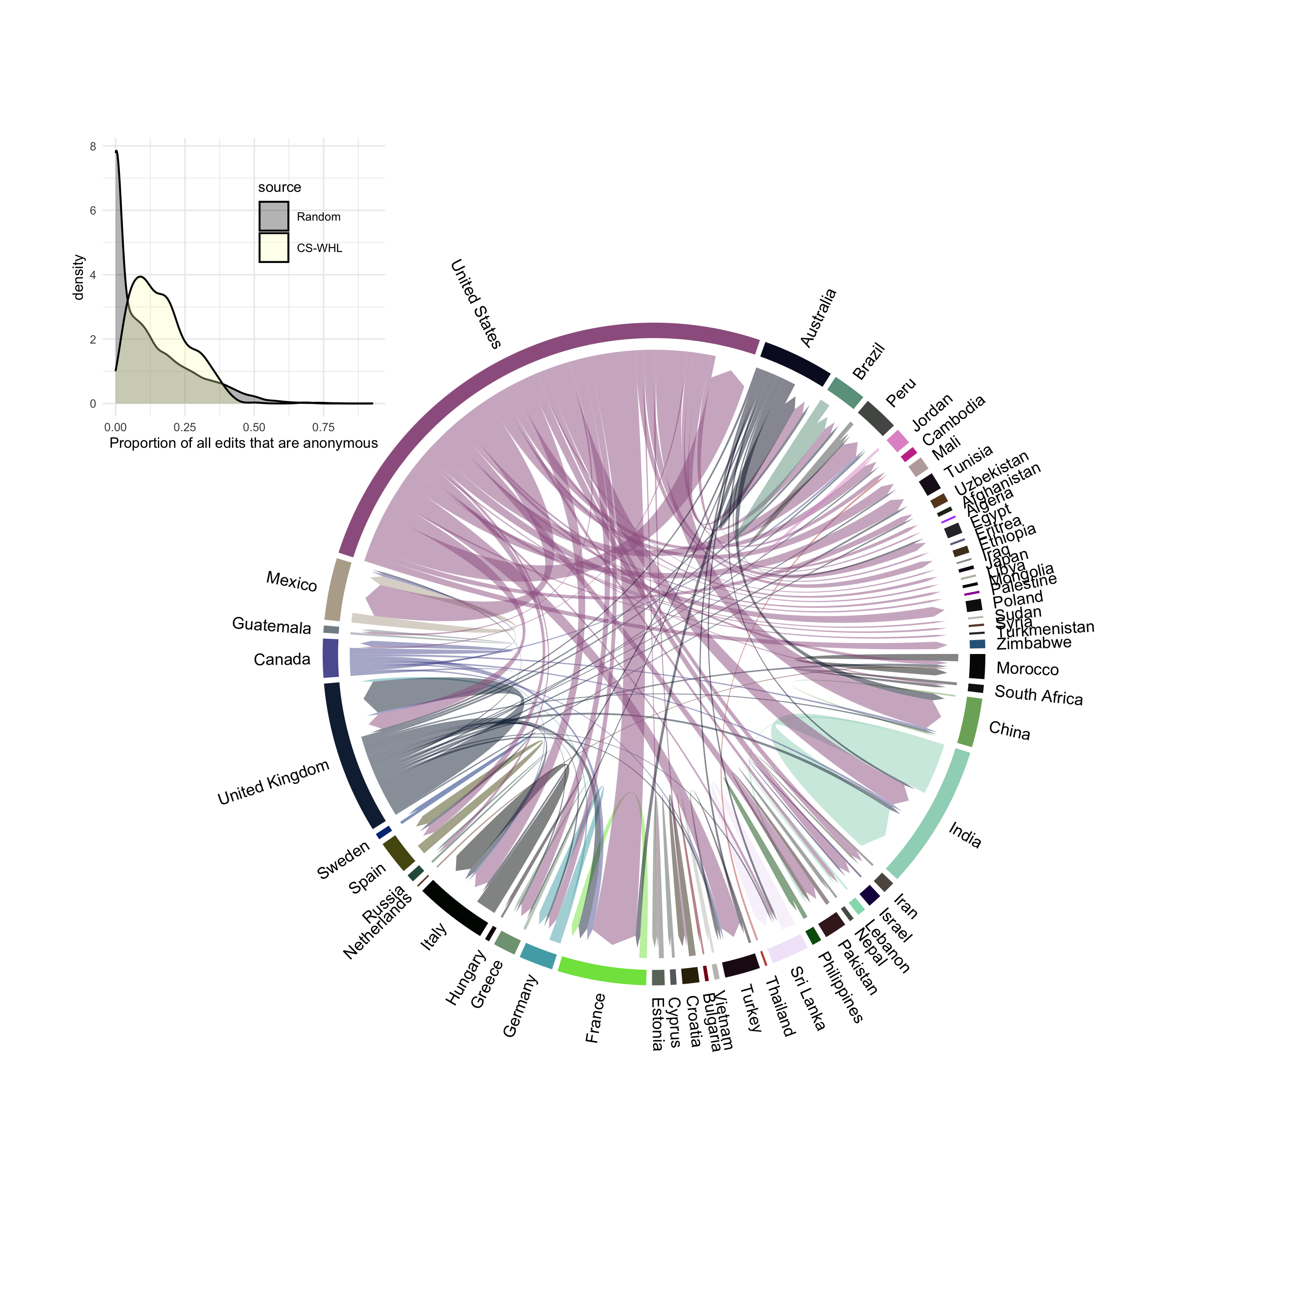

Figure 8: Flow of edits by location on Wikipedia for articles about Cultural Sites on the UNESCO World Heritage List. The arrows indicate the country where the editor is location (arrow nock or start) and the location of the CS-WHL site that they are editing the article of (arrow point or end). Editor locations were determined by geo-locating the IP addresses associated with anonymous edits. Inset shows the distribution of proportions of edits per article that are anonymous. Non-anonymous edits are identitifed by Wikipedia usernames, rather than IP addresses, and cannot be geo-located.

Spatial patterns in the coverage of CS-WHL sites on Wikipedia closely resemble the physical distribution of sites. Figure 7 shows that most countries have between 2-3 CS-WHL on Wikipedia, with Germany, India, China, France and Spain being the countries with the most articles about their CS-WHL. This pattern is consistent with Graham et al. (2014)’s observations that places in the Global North tend to be over-represented on Wikipedia. The lower panel of figure 7 further demontrates this with South American countries having low proportions of their CS-WHL sites represented on Wikipedia. The pattern in African countries is that they either have a very small number of sites that are all on Wikipedia (indicated by yellow on the figure), or they do not have any CS-WHL at all. More surprising is the distribution of editor locations shown in figure 8, which we determined by geo-locating the IP addresses attached to each anonymous edit on all CS-WHL articles. This figure shows the flow of edits, with the arrows starting at the country where the editor was located when they made their edit, and ending at the country where the CS-WHL site that they are editing is located. The inset plot on figure 8 shows that this visualisation only accounts for a relatively small proportion of all edits to CS-WHL articles. Around 20% of edits of most CS-WHL articles are anonymous, a higher proportion than our random sample. Nevertheless, there are 79,077 anonymous edits, and so this sample likely contains a non-random signal. The most striking detail in figure 8 is the large proportion of edits that originate in the United States, and that the vast majority of these are edits of articles about CS-WHL sites located elsewhere in the world. The country with the next largest proportion, the United Kingdom, is less than half of the United States, and a much greater proportion of edits originating in the UK are on articles about CS-WHL sites located in the UK, compared to the US. The country with the next highest proportion of editors is India, and nearly half of those edits are on CS-WHL sites located India. The majority of countries in this chord diagram indicate that articles about CS-WHL sites in those countries receive edits from editors located elsewhere, mostly the US and other English-speaking countries.

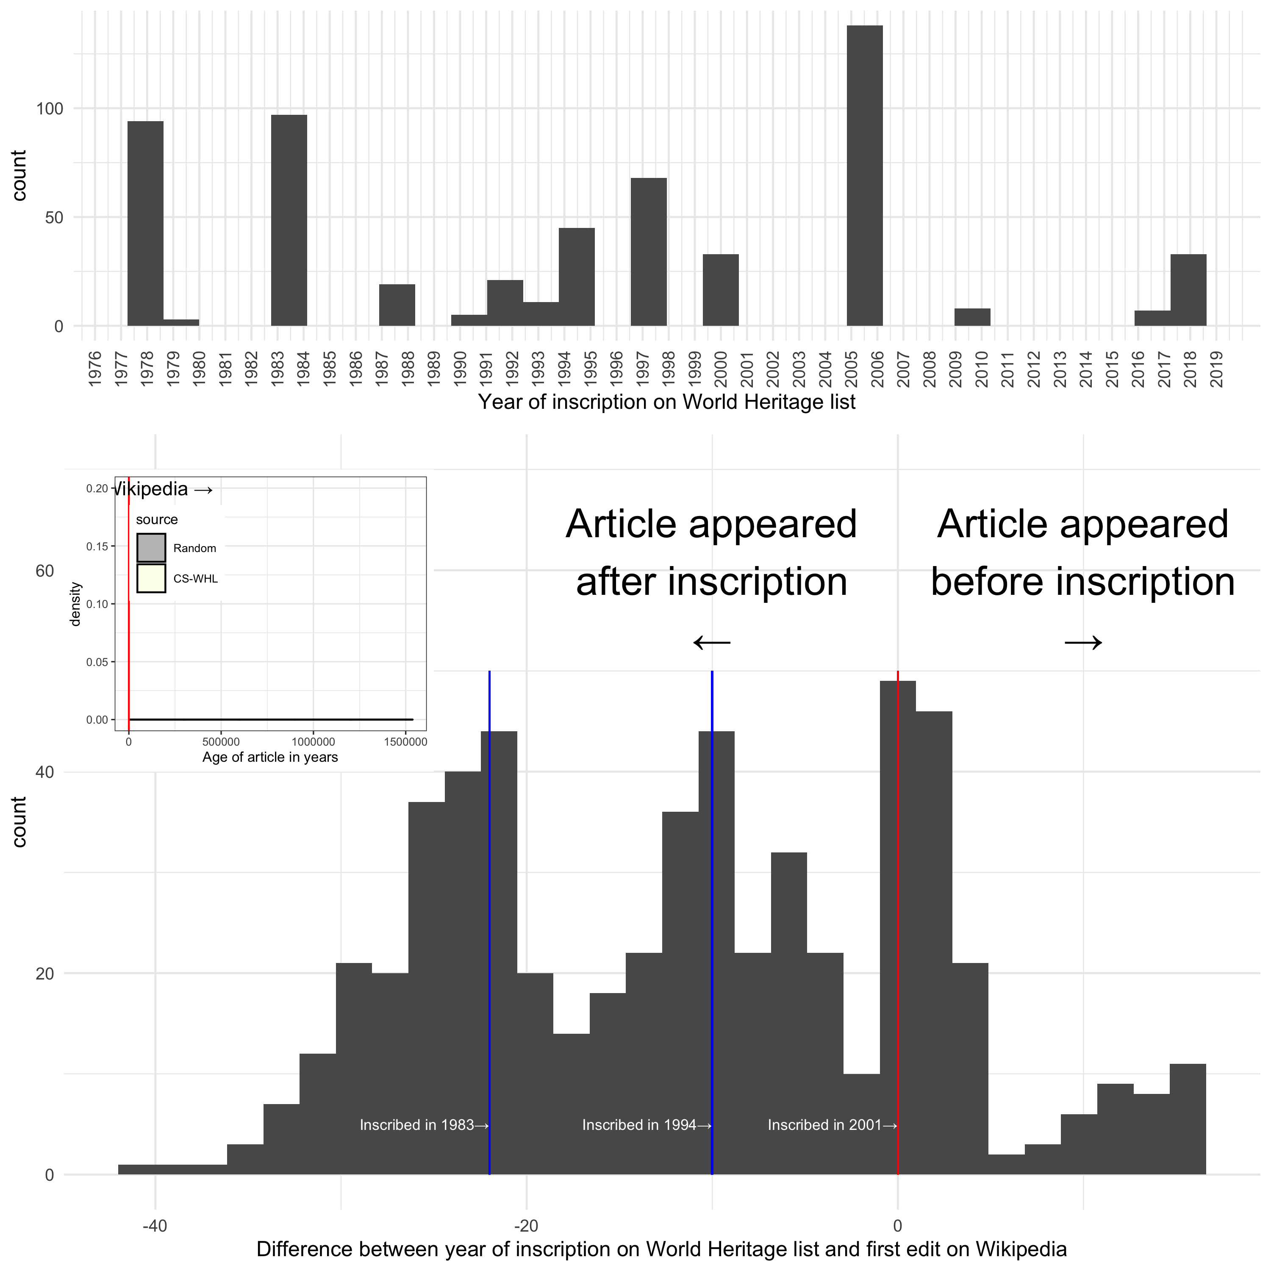

Figure 9: Article editing relative to WHL inscription date. Upper panel is a histogram of WHL inscription years. Lower panel is a histogram of duration between inscription and the appearance of the Wikipedia article. Inset shows the distribution of CS-WHL article ages and ages of random sites.

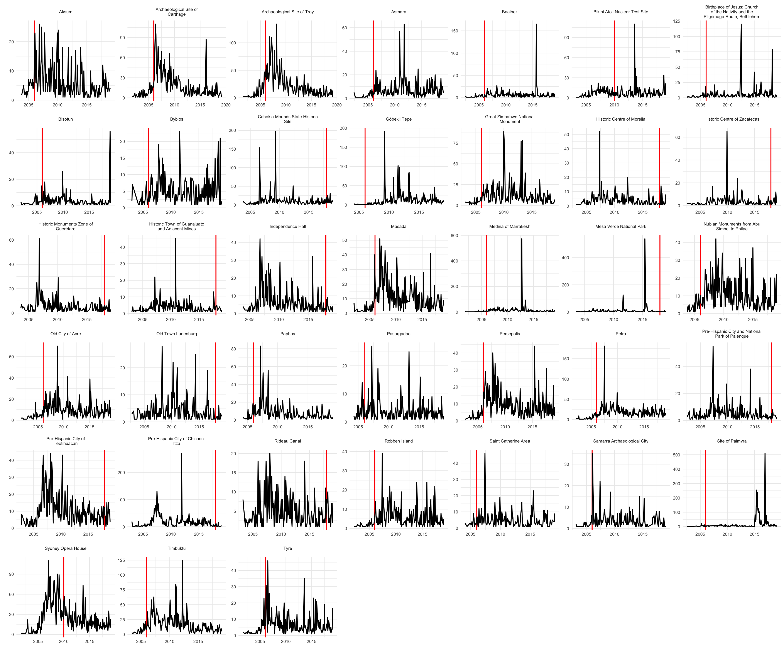

Figure 10: Time series of editing activity for CS-WHL articles for all sites inscribed after Wikipedia began in 2001, and with a minimum of 150 edits in total

Time series analysis of edits on articles about CS-WHL sites can help us identify relationships between activity on Wikipedia articles and external events related to the sites. Figure 9 shows that most articles about CS-WHL sites are much older than articles in our random sample, with most CS-WHL articles created 5-10 years after Wikipedia first appeared in 2001. This rapid addition of articles early in the life of Wikipedia supports the observation from the in-bound Wikilinks data that articles about CS-WHL sites are more central to the encyclopedia and considered worthy of inclusion than many other types of articles. The distribution of years between the date of a site’s inscription on the WHL and the date of the creation of that site’s Wikipedia article has a distinctive trimodal shape. The first two modes reflect the relatively large number of sites inscribed on the WHL in 1983 and the early 1990s. The third mode at the zero point on the horizontal axis corresponds to articles that were created in or around the year the CS-WHL site was inscribed on the list. These are sites inscribed after the creation of Wikipedia in 2001. Only a relatively small proportion of CS-WHL sites had Wikipedia articles created about them before they were inscribed on the WHL, because the majority of sites were inscribed before Wikipedia was created. The time series of editing activity at individual sites are highly variable and show display complex patterns (Figure 10). Timbuktu shows spikes of editing activity right after the rebel attacks in mid June 2012, with descriptions of the attacks added to the text of the article at that time. However the tallest peak in editing activity on the Timbuktu occurs earlier, in April 2012, those edits concentrated on expanding the sections on local prehistory. A detailed analysis of all the article-specific time series is beyond the scope of this paper, but we can see several patterns that suggestion interesting relationships between editorial activity and WHL listing. For example, editing activity spiking sharply at the time of WHL inscription (e.g. Tyre, Masada), editorial activity spiking at the time of WHL inscription and slowly decaying to a baseline level (e.g. Carthage), editorial activity that peaks shortly after the time of WHL inscription (e.g. Troy, Masada), and many sites where editorial activity that shows no signal at all at the time of WHL inscription (Figure 10).

# Discussion

Our results establish Wikipedia as site and community demonstrating active engagement with cultural heritage (Pentzold et al., 2017), especially cultural sites on the UNESCO World Heritage List. We have defined Wikipedia as an online peer production community with technical and cultural qualities that separate it from social media such as Twitter and Facebook. Editing mechanics, bots, reverts, and talk pages work together to enable and limit discourse and debate about CS-WHL on Wikipedia. The goal-driven culture of Wikipedia editors, and the organisation’s policies that guide the production of articles strongly constrain heritage discourse, such that the exchange of different perspectives are rarely found in articles themselves, but buried in technical and highly specific discussions on article talk pages. Our results show how these distinctive qualities generate a technicity that shapes how people engage with elements of the past and attribute social and cultural meanings on Wikipedia. These resemble the “contingent collaborations” and “productive frictions” described by Tsing (2011) where local, individual actions of knowledge creation are circumscribed by forces and structures that encompass their expression, but also give meaning to their interactions.

We found that many of the Wikipedia articles about CS-WHL are central to the encyclopedia project. Many of them were among the first articles written for the encyclopedia, are more frequently viewed, are more frequently linked to by other articles, are longer, and more intensively edited by a greater variety of editors, than the average article. These results indicate the high value that Wikipedia users place on CS-WHL, consistent with the goal of the UNESCO World Heritage Committee to maintain a list reflects the world’s cultural diversity of outstanding universal value. However, we found that sites are unequally valued, in predictable ways, given prior work on the demographics of Wikipedia users and editors, and the Eurocentric value system of the World Heritage Committee (Cleere, 2003; Smith, 2006, p. 98). CS-WHL in countries in the Global South are under-represented on Wikipedia, a geographical tension that is also evident in the World Heritage List (Brumann, 2014). They are also shorter and received less attention in the form of page views and inward Wikilinks.

Perhaps the most striking spatial pattern in our results is how much of the edits to CS-WHL articles in any part of the world come from the United States. The anonymous editors of articles about CS-WHL are generally not located in the same country as the site they are editing. This suggests a digital colonialism of world heritage information on Wikipedia, where heritage is interpreted and communicated by people who are not part of the descendant community traditionally associated with the site. This is an important observation because it is these editors that control the production of knowledge about CS-WHL articles, and the ability to control information about heritage has several implications. First is that the choices of these editors define community identity, that is, the community of Wikipedia editors, and also the broader community of Internet users that read Wikipedia, by indicating which sites are important and visible, and which are not by contributing to a digital ‘authorized heritage discourse’ (Smith and Waterton, 2012) that prioritizes their own self-interests. Second is that traditional communities associated with CS-WHL have little control over how their own heritage is represented on Wikipedia. We see this spatial pattern on Wikipedia as part of a trend of globalization of heritage, where places that had traditionally contributed to local or regional identities are turned into sanitized playgrounds for rich tourists (Bernbeck and Pollock, 2004). Wikipedia may be seen as virtual playground for Americans to construct a universal heritage that reflects their neo-liberal cultural values, and validates their identities, perhaps reflecting a cultural rhetoric of ‘heritage populism’ (Reynié, 2016). In this way, the representation of heritage on Wikipedia recapitulates a long-standing tradition of colonial subordination of one group’s heritage and identity by a more powerful and dominant group.

This colonial logic may help to explain our findings of minimal conflicts surrounding the production of Wikipedia articles about CS-WHL. We found that bot activity, numbers of revert edits, and edits relating to vandalism for CS-WHL articles were comparable to or less than other sites. Most of this activity relates to playful vandalism and occurred on uncontroversial CS-WHL sites such as the Sydney Opera House and the Tower of London. Controversial sites, identified by the presence of military or diplomatic conflicts, were not prominent in these metrics. Our analysis of the talk pages of CS-WHL articles shows that they are often longer than a typical Wikipedia article, and are the location where conflict is most evidence. While much of the conflict is highly technical and local about the policies and processes of editing Wikipedia, we did observe signs of the political and military conflict at CS-WHL played out on some of the talk pages, such as Mapungubwe and Preah Vihear. We interpret this as editors exploiting the talk pages for behind-the-scenes heritage activism. The technical and cultural constraints of writing directly on the article page mean that the talk page is the only suitable location for negotiating disputes whose eventual trace in the edit history of the article might be negligible. We found that some CS-WHL talk pages referenced a ‘Geopolitical, ethnic, and religious conflicts noticeboard’ elsewhere on Wikipedia, as a forum for arbitration of disputes created in 2008 following a recommendation by an investigation into edit wars on articles about Northern Ireland (The Troubles), Palestine-Israel and other locations with ethnic or cultural based conflicts. However the noticeboard was closed in 2012 due to an absence of activity. Overall we find that editors of CS-WHL articles appear conflict-averse, probably because many of them come from similar cultural, socio-economic and educational backgrounds, and so share similar values about heritage that align with their shared goal of making an encyclopedia. The low levels of conflict reflect the continuity between the printed encyclopedia project as a compendium of universal knowledge, and the World Heritage List as universal heritage. These projects share origins in the cultural elites of Western European, and their distinctive sense of what is universal that is linked to nineteenth-century nationalism and liberal modernity (Smith, 2006).

The results of our time series analyses reveal complex patterns in how heritage-related concerns are realized on Wikipedia. Some sites show spikes in Wikipedia editing activity that are directly related to the inscription of the site on the WHL, or conflict events at the site. However at other sites the rhythms of editing activity seem unrelated to events directly related to the site. Like the talk pages, which have unrealised potential for close reading of heritage activism and disputes, close study individual edit histories of CS-WHL articles may reveal further patterns of how people engage with heritage on Wikipedia.

# Conclusion

The agency of people participating in heritage-related activities on Wikipedia is highly constrained by the technical characteristics of editing, bots, and consensus-valuing culture. Although there are some niches where editors can debate, concerns about state-like actors, violence & destruction, deal-making, etc. are poorly represented. Typical conflicts about Wikipedia CS-WHL articles are hyper-local, and process-centered. Spatial patterns in the edits to Wikipedia articles about CS-WHL show a kind of digital colonialism of world heritage information, with most edits emanating from the United States. Because of these technical and cultural characteristics of Wikipedia, its articles present a discourse that actively obscures the power relations that give rise to them, and makes opaque debates about how heritage is involved in the production of identity and power (cf. Harvey, 2001).

That said, Wikipedia is valuable and important as a Big Data source of social information on heritage for several reasons. Although it lacks the velocity of other social media, such as Twitter, it preserves a distinctively complex record of human interactions with the past at simultaneously high scales, high resolution, and in highly structured ways, afforded by no other platform. As a non-profit entity, Wikipedia’s data are freely available to researchers, unlike Twitter and Facebook. This has important ethical implications because it eliminates the need for academic collaboration with commercial platforms, whose business interests may not align with the researchers’ ethics (Schroeder, 2014). ALthough free of these commercial interests, a different set of ethics is implied by the exquisite administrative and technical complexity of Wikipedia. These structures serve to normalize and historize inequalities, and manage threats to models of control and expertise about heritage (Harrison, 2015). As a context of heritage production, a resource of information on heritage, and an artefact of contemporary digital heritage, Wikipedia is remarkable and holds substantial research potential. While the Neutral Point of View is a central policy for Wikipedia articles, representations and definitions of cultural heritage are never neutral in any discourse, because it always comes from some perspective (Lähdesmäki, 2019). Given the tremendous popularity and visibility of Wikipedia, is it important that future work on digital heritage in this context continue to critically examine what is absent from, and uncontested in, Wikipedia, and who benefits and suffers from these absences.

# Acknowledgements

Thanks to Chiara Bonacchi, Rodney Harrison, and Daniel Pett for inviting BM to present this work at the “Digital Heritage in a World of Big Data” conference at the University of Stirling, Scotland, May 2019. This conference was part of the AHRC-funded project ‘Ancient Identities in Modern Britain’ and the AHRC Heritage Priority Area Leadership Fellowship.

# References

Adams, J., Brückner, H., 2015. Wikipedia, sociology, and the promise and pitfalls of big data. Big Data & Society 2, 2053951715614332.

Baker, F., 2003. The red army graffiti in the reichstag, berlin: Politics of rock-art in a contemporary european urban landscape, in: European Landscapes of Rock-Art. Routledge, pp. 38–56.

Bernbeck, R., Pollock, S., 2004. The political economy of archaeological practice and the production of heritage in the middle east. A companion to social archaeology 335–352.

Bertacchini, E., Liuzza, C., Meskell, L., Saccone, D., 2016. The politicization of unesco world heritage decision making. Public Choice 167, 95–129.

Bonacchi, C., Krzyzanska, M., 2019. Digital heritage research re-theorised: Ontologies and epistemologies in a world of big data. International Journal of Heritage Studies 25, 1235–1247.

Breiman, L., 2001. Random forests. Machine learning 45, 5–32.

Brioschi, G., 2017. Discourses of heritage: UNESCO and the local community in timbuktu (PhD thesis). Brussels School of International Studies.

Brumann, C., 2014. Shifting tides of world-making in the unesco world heritage convention: Cosmopolitanisms colliding. Ethnic and Racial Studies 37, 2176–2192.

Campello, R.J., Moulavi, D., Sander, J., 2013. Density-based clustering based on hierarchical density estimates, in: Pacific-Asia Conference on Knowledge Discovery and Data Mining. Springer, pp. 160–172.

Cantino, A., Maxwell, K., 2017. SelectorGadget: Point and click css selectors.

Cao, Y., Mehta, H., Norcross, A.E., Taniguchi, M., Lindsey, J.S., 2020. Analysis of wikipedia pageviews to identify popular chemicals, in: Reporters, Markers, Dyes, Nanoparticles, and Molecular Probes for Biomedical Applications Xii. International Society for Optics; Photonics, p. 112560I.

Cleere, H., 2003. The uneasy bedfellows: Universality and cultural heritage, in: Destruction and Conservation of Cultural Property. Routledge, pp. 38–45.

Coningham, R., Lewer, N., 1999. Paradise lost: The bombing of the temple of the tooth—a unesco world heritage site in sri lanka. Antiquity 73, 857–866.

Falser, M., 2015. Representing heritage without territory—the khmer rouge at the unesco in paris during the 1980s and their political strategy for angkor, in: Cultural Heritage as Civilizing Mission. Springer, pp. 225–249.

Ford, H., Wajcman, J., 2017. “Anyone can edit”, not everyone does: Wikipedia’s infrastructure and the gender gap. Social studies of science 47, 511–527.

Geiger, R.S., 2014. Bots, bespoke, code and the materiality of software platforms. Information, Communication & Society 17, 342–356.

Geiger, R.S., 2009. The social roles of bots and assisted editing programs, in: Proceedings of the 5th International Symposium on Wikis and Open Collaboration. pp. 1–2.

Geiger, R.S., Halfaker, A., 2017. Operationalizing conflict and cooperation between automated software agents in wikipedia: A replication and expansion of’even good bots fight’. Proceedings of the ACM on Human-Computer Interaction 1, 1–33.

Gornik, V., 2015. Can unesco do more to counter terrorists’ destruction of world heritage? Present Pasts 6.

Graham, M., Hogan, B., Straumann, R.K., Medhat, A., 2014. Uneven geographies of user-generated information: Patterns of increasing informational poverty. Annals of the Association of American Geographers 104, 746–764.

Harrison, R., 2015. Beyond “natural” and “cultural” heritage: Toward an ontological politics of heritage in the age of anthropocene. Heritage & Society 8, 24–42.

Harrison, R., 2013. Forgetting to remember, remembering to forget: Late modern heritage practices, sustainability and the “crisis” of accumulation of the past. International Journal of Heritage Studies 19, 579–595.

Harvey, D.C., 2001. Heritage pasts and heritage presents: Temporality, meaning and the scope of heritage studies. International journal of heritage studies 7, 319–338.

Hill, B., Shaw, A., 2013. The wikipedia gender gap revisited: Characterizing survey response bias with propensity score estimation. PLoS ONE 8.

Ho-Dac, L.-M., Laippala, V., Poudat, C., Tanguy, L., 2017. Exploring wikipedia talk pages for conflict detection. Book series Translation Studies and Applied Linguistics 146.

Ho-Dac, L.-M., Laippala, V., Poudat, C., Tanguy, L., 2016. French wikipedia talk pages: Profiling and conflict detection, in: 4th Conference on Cmc and Social Media Corpora for the Humanities, Sep 2016, Ljubljana, Slovenia.

Iba, T., Nemoto, K., Peters, B., Gloor, P.A., 2010. Analyzing the creative editing behavior of wikipedia editors: Through dynamic social network analysis. Procedia-Social and Behavioral Sciences 2, 6441–6456.

Johnson, I.L., Lin, Y., Li, T.J.-J., Hall, A., Halfaker, A., Schöning, J., Hecht, B., 2016. Not at home on the range: Peer production and the urban/rural divide, in: Proceedings of the 2016 Chi Conference on Human Factors in Computing Systems. pp. 13–25.

Kietzmann, J.H., Hermkens, K., McCarthy, I.P., Silvestre, B.S., 2011. Social media? Get serious! Understanding the functional building blocks of social media. Business horizons 54, 241–251.

Kittur, A., Suh, B., Pendleton, B.A., Chi, E.H., 2007. He says, she says: Conflict and coordination in wikipedia, in: Proceedings of the Sigchi Conference on Human Factors in Computing Systems. pp. 453–462.

Kristiansen, K., 2014. Towards a new paradigm. The third science revolution and its possible consequences in archaeology. Current Swedish Archaeology 22, 11–71.

Krzyzanska, M.A., Chiara Bonacchi, 2018. The heritage of brexit: Roles of the past in the construction of political identities through social media - chiara bonacchi, mark altaweel, marta krzyzanska, 2018. Journal of Social Archaeology.

Lähdesmäki, T., 2019. Conflicts and reconciliation in the postmillennial heritage-policy discourses of the council of europe and the european union, in: Dissonant Heritages and Memories in Contemporary Europe. Springer, pp. 25–50.

Locard, H., 2015. The myth of angkor as an essential component of the khmer rouge utopia, in: Cultural Heritage as Civilizing Mission. Springer, pp. 201–222.

Marwick, B., 2017. Computational reproducibility in archaeological research: Basic principles and a case study of their implementation. Journal of Archaeological Method and Theory 24, 424–450.

Marwick, B., Boettiger, C., Mullen, L., 2018. Packaging data analytical work reproducibly using r (and friends). The American Statistician 72, 80–88.

McInnes, L., Healy, J., Melville, J., 2018. Umap: Uniform manifold approximation and projection for dimension reduction. arXiv preprint arXiv:1802.03426.

McIver, D.J., Brownstein, J.S., 2014. Wikipedia usage estimates prevalence of influenza-like illness in the united states in near real-time. PLoS computational biology 10.

Meskell, L., 2018. A future in ruins: UNESCO, world heritage, and the dream of peace. Oxford University Press.

Meskell, L., 2016. World heritage and wikileaks: Territory, trade and temples on the thai-cambodian border. Current Anthropology 57.

Meskell, L., 2015. Gridlock: UNESCO, global conflict and failed ambitions. World Archaeology 47, 225–238.

Meskell, L., 2012. The rush to inscribe: Reflections on the 35th session of the world heritage committee, unesco paris, 2011. Journal of Field Archaeology 37, 145–151.

Meskell, L., 2011. From paris to pontdrift: UNESCO meetings, mapungubwe and mining. THE SOUTH AFRICAN ARCHAEO LOGICAL BULLETIN 149–156.

Niederer, S., Van Dijck, J., 2010. Wisdom of the crowd or technicity of content? Wikipedia as a sociotechnical system. New Media & Society 12, 1368–1387.

Pentzold, C., Weltevrede, E., Mauri, M., Laniado, D., Kaltenbrunner, A., Borra, E., 2017. Digging wikipedia: The online encyclopedia as a digital cultural heritage gateway and site. Journal on Computing and Cultural Heritage (JOCCH) 10, 1–19.

Pfanzelter, E., 2015. At the crossroads with public history: Mediating the holocaust on the internet. Holocaust Studies 21, 250–271.

Priedhorsky, R., Chen, J., Lam, S.(.K., Panciera, K., Terveen, L., Riedl, J., 2007. Creating, destroying, and restoring value in wikipedia, in: Proceedings of the 2007 International Acm Conference on Supporting Group Work. pp. 259–268.

R Core Team, 2020. R: A language and environment for statistical computing. R Foundation for Statistical Computing, Vienna, Austria.

Reynié, D., 2016. The specter haunting europe:" Heritage populism" and france’s national front. Journal of Democracy 27, 47–57.

Roll, U., Mittermeier, J.C., Diaz, G.I., Novosolov, M., Feldman, A., Itescu, Y., Meiri, S., Grenyer, R., 2016. Using wikipedia page views to explore the cultural importance of global reptiles. Biological conservation 204, 42–50.

Schneider, J., Passant, A., Breslin, J.G., 2012. A content analysis: How wikipedia talk pages are used.

Schroeder, R., 2014. Big data and the brave new world of social media research. Big Data & Society 1, 2053951714563194.

Shaw, A., Hargittai, E., 2018. The pipeline of online participation inequalities: The case of wikipedia editing. Journal of communication 68, 143–168.

Shaw, A., Hill, B.M., 2014. Laboratories of oligarchy? How the iron law extends to peer production. Journal of Communication 64, 215–238.

Smith, L., 2006. Uses of heritage. Routledge.

Smith, L., Waterton, E., 2012. Constrained by commonsense: The authorized heritage discourse in contemporary debates. The Oxford handbook of public archaeology 153–171.

Sothirak, P., 2013. Cambodia’s border conflict with thailand. Southeast Asian Affairs 2013, 87–100.

Suh, B., Chi, E.H., Pendleton, B.A., Kittur, A., 2007. Us vs. Them: Understanding social dynamics in wikipedia with revert graph visualizations, in: 2007 Ieee Symposium on Visual Analytics Science and Technology. IEEE, pp. 163–170.

Tsing, A.L., 2011. Friction: An ethnography of global connection. Princeton University Press.

Tsvetkova, M., Garcı́a-Gavilanes, R., Floridi, L., Yasseri, T., 2017. Even good bots fight: The case of wikipedia. PloS one 12.

Von Droste, B., 2011. The concept of outstanding universal value and its application. Journal of cultural heritage management and sustainable development.

Weltevrede, E., Borra, E., 2016. Platform affordances and data practices: The value of dispute on wikipedia. Big Data & Society 3, 2053951716653418.

Wickham, H., 2019. Rvest: Easily harvest (scrape) web pages.

Wilkinson, D.M., 2008. Strong regularities in online peer production, in: Proceedings of the 9th Acm Conference on Electronic Commerce. pp. 302–309.

Wolniewicz-Slomka, D., 2016. Framing the holocaust in popular knowledge: 3 articles about the holocaust in english, hebrew and polish wikipedia. Adeptus 29–49.

Yasseri, T., Sumi, R., Rung, A., Kornai, A., Kertész, J., 2012. Dynamics of conflicts in wikipedia. PloS one 7, e38869.

Zheng, L., Albano, C.M., Vora, N.M., Mai, F., Nickerson, J.V., 2019. The roles bots play in wikipedia. Proceedings of the ACM on Human-Computer Interaction 3, 1–20.

### Colophon

This report was generated on 2020-06-08 00:38:03 using the following computational environment and dependencies:

#> ─ Session info ───────────────────────────────────────────────────────────────  
#> setting value   
#> version R version 4.0.0 (2020-04-24)  
#> os macOS Catalina 10.15.2   
#> system x86_64, darwin17.0   
#> ui X11   
#> language (EN)   
#> collate en_US.UTF-8   
#> ctype en_US.UTF-8   
#> tz America/Los_Angeles   
#> date 2020-06-08   
#>   
#> ─ Packages ───────────────────────────────────────────────────────────────────  
#> package * version date lib source   
#> abind 1.4-5 2016-07-21 [1] CRAN (R 4.0.0)   
#> assertthat 0.2.1 2019-03-21 [1] CRAN (R 4.0.0)   
#> backports 1.1.7 2020-05-13 [1] CRAN (R 4.0.0)   
#> base64enc 0.1-3 2015-07-28 [1] CRAN (R 4.0.0)   
#> blob 1.2.1 2020-01-20 [1] CRAN (R 4.0.0)   
#> bookdown 0.19 2020-05-15 [1] CRAN (R 4.0.0)   
#> broom 0.5.6 2020-04-20 [1] CRAN (R 4.0.0)   
#> callr 3.4.3 2020-03-28 [1] CRAN (R 4.0.0)   
#> caret * 6.0-86 2020-03-20 [1] CRAN (R 4.0.0)   
#> cellranger 1.1.0 2016-07-27 [1] CRAN (R 4.0.0)   
#> circlize * 0.4.9 2020-04-30 [1] CRAN (R 4.0.0)   
#> class 7.3-17 2020-04-26 [1] CRAN (R 4.0.0)   
#> classInt 0.4-3 2020-04-07 [1] CRAN (R 4.0.0)   
#> cli 2.0.2 2020-02-28 [1] CRAN (R 4.0.0)   
#> codetools 0.2-16 2018-12-24 [1] CRAN (R 4.0.0)   
#> colorspace 1.4-1 2019-03-18 [1] CRAN (R 4.0.0)   
#> cowplot * 1.0.0 2019-07-11 [1] CRAN (R 4.0.0)   
#> crayon 1.3.4 2017-09-16 [1] CRAN (R 4.0.0)   
#> crosstalk 1.1.0.1 2020-03-13 [1] CRAN (R 4.0.0)   
#> curl 4.3 2019-12-02 [1] CRAN (R 4.0.0)   
#> data.table 1.12.8 2019-12-09 [1] CRAN (R 4.0.0)   
#> DBI 1.1.0 2019-12-15 [1] CRAN (R 4.0.0)   
#> dbplyr 1.4.4 2020-05-27 [1] CRAN (R 4.0.0)   
#> dbscan * 1.1-5 2019-10-23 [1] CRAN (R 4.0.0)   
#> desc 1.2.0 2018-05-01 [1] CRAN (R 4.0.0)   
#> devtools 2.3.0 2020-04-10 [1] CRAN (R 4.0.0)   
#> dichromat 2.0-0 2013-01-24 [1] CRAN (R 4.0.0)   
#> digest 0.6.25 2020-02-23 [1] CRAN (R 4.0.0)   
#> dplyr * 1.0.0 2020-05-29 [1] CRAN (R 4.0.0)   
#> e1071 1.7-3 2019-11-26 [1] CRAN (R 4.0.0)   
#> ellipsis 0.3.1 2020-05-15 [1] CRAN (R 4.0.0)   
#> evaluate 0.14 2019-05-28 [1] CRAN (R 4.0.0)   
#> fansi 0.4.1 2020-01-08 [1] CRAN (R 4.0.0)   
#> farver 2.0.3 2020-01-16 [1] CRAN (R 4.0.0)   
#> forcats * 0.5.0 2020-03-01 [1] CRAN (R 4.0.0)   
#> foreach 1.5.0 2020-03-30 [1] CRAN (R 4.0.0)   
#> fs 1.4.1 2020-04-04 [1] CRAN (R 4.0.0)   
#> generics 0.0.2 2018-11-29 [1] CRAN (R 4.0.0)   
#> ggplot2 * 3.3.1 2020-05-28 [1] CRAN (R 4.0.0)   
#> ggrepel * 0.9.0 2020-05-11 [1] Github (slowkow/ggrepel@3941cf1)  
#> GlobalOptions 0.1.1 2019-09-30 [1] CRAN (R 4.0.0)   
#> glue 1.4.1 2020-05-13 [1] CRAN (R 4.0.0)   
#> gower 0.2.1 2019-05-14 [1] CRAN (R 4.0.0)   
#> gridGraphics 0.5-0 2020-02-25 [1] CRAN (R 4.0.0)   
#> gtable 0.3.0 2019-03-25 [1] CRAN (R 4.0.0)   
#> haven 2.3.0 2020-05-24 [1] CRAN (R 4.0.0)   
#> here 0.1 2017-05-28 [1] CRAN (R 4.0.0)   
#> highr 0.8 2019-03-20 [1] CRAN (R 4.0.0)   
#> hms 0.5.3 2020-01-08 [1] CRAN (R 4.0.0)   
#> htmltools 0.4.0 2019-10-04 [1] CRAN (R 4.0.0)   
#> htmlwidgets 1.5.1 2019-10-08 [1] CRAN (R 4.0.0)   
#> httr 1.4.1 2019-08-05 [1] CRAN (R 4.0.0)   
#> ipred 0.9-9 2019-04-28 [1] CRAN (R 4.0.0)   
#> iterators 1.0.12 2019-07-26 [1] CRAN (R 4.0.0)   
#> jsonlite 1.6.1 2020-02-02 [1] CRAN (R 4.0.0)   
#> KernSmooth 2.23-17 2020-04-26 [1] CRAN (R 4.0.0)   
#> knitr 1.28 2020-02-06 [1] CRAN (R 4.0.0)   
#> labeling 0.3 2014-08-23 [1] CRAN (R 4.0.0)   
#> lattice * 0.20-41 2020-04-02 [1] CRAN (R 4.0.0)   
#> lava 1.6.7 2020-03-05 [1] CRAN (R 4.0.0)   
#> leafem 0.1.1 2020-04-05 [1] CRAN (R 4.0.0)   
#> leaflet 2.0.3 2019-11-16 [1] CRAN (R 4.0.0)   
#> leafsync 0.1.0 2019-03-05 [1] CRAN (R 4.0.0)   
#> lifecycle 0.2.0 2020-03-06 [1] CRAN (R 4.0.0)   
#> lubridate * 1.7.8 2020-04-06 [1] CRAN (R 4.0.0)   
#> lwgeom 0.2-4 2020-05-20 [1] CRAN (R 4.0.0)   
#> magrittr 1.5 2014-11-22 [1] CRAN (R 4.0.0)   
#> MASS 7.3-51.6 2020-04-26 [1] CRAN (R 4.0.0)   
#> Matrix * 1.2-18 2019-11-27 [1] CRAN (R 4.0.0)   
#> memoise 1.1.0 2017-04-21 [1] CRAN (R 4.0.0)   
#> ModelMetrics 1.2.2.2 2020-03-17 [1] CRAN (R 4.0.0)   
#> modelr 0.1.8 2020-05-19 [1] CRAN (R 4.0.0)   
#> munsell 0.5.0 2018-06-12 [1] CRAN (R 4.0.0)   
#> nlme 3.1-148 2020-05-24 [1] CRAN (R 4.0.0)   
#> nnet 7.3-14 2020-04-26 [1] CRAN (R 4.0.0)   
#> patchwork * 1.0.0 2019-12-01 [1] CRAN (R 4.0.0)   
#> pillar 1.4.4 2020-05-05 [1] CRAN (R 4.0.0)   
#> pkgbuild 1.0.8 2020-05-07 [1] CRAN (R 4.0.0)   
#> pkgconfig 2.0.3 2019-09-22 [1] CRAN (R 4.0.0)   
#> pkgload 1.1.0 2020-05-29 [1] CRAN (R 4.0.0)   
#> plyr 1.8.6 2020-03-03 [1] CRAN (R 4.0.0)   
#> png 0.1-7 2013-12-03 [1] CRAN (R 4.0.0)   
#> prettyunits 1.1.1 2020-01-24 [1] CRAN (R 4.0.0)   
#> pROC 1.16.2 2020-03-19 [1] CRAN (R 4.0.0)   
#> processx 3.4.2 2020-02-09 [1] CRAN (R 4.0.0)   
#> prodlim 2019.11.13 2019-11-17 [1] CRAN (R 4.0.0)   
#> ps 1.3.3 2020-05-08 [1] CRAN (R 4.0.0)   
#> purrr * 0.3.4 2020-04-17 [1] CRAN (R 4.0.0)   
#> R6 2.4.1 2019-11-12 [1] CRAN (R 4.0.0)   
#> ranger 0.12.1 2020-01-10 [1] CRAN (R 4.0.0)   
#> raster 3.1-5 2020-04-19 [1] CRAN (R 4.0.0)   
#> RColorBrewer 1.1-2 2014-12-07 [1] CRAN (R 4.0.0)   
#> Rcpp 1.0.4.6 2020-04-09 [1] CRAN (R 4.0.0)   
#> RcppAnnoy 0.0.16 2020-03-08 [1] CRAN (R 4.0.0)   
#> readr * 1.3.1 2018-12-21 [1] CRAN (R 4.0.0)   
#> readxl 1.3.1 2019-03-13 [1] CRAN (R 4.0.0)   
#> recipes 0.1.12 2020-05-01 [1] CRAN (R 4.0.0)   
#> remotes 2.1.1 2020-02-15 [1] CRAN (R 4.0.0)   
#> reprex 0.3.0 2019-05-16 [1] CRAN (R 4.0.0)   
#> reshape2 1.4.4 2020-04-09 [1] CRAN (R 4.0.0)   
#> rgeolocate * 1.3.1 2020-05-17 [1] CRAN (R 4.0.0)   
#> rgeos 0.5-3 2020-05-08 [1] CRAN (R 4.0.0)   
#> rlang 0.4.6 2020-05-02 [1] CRAN (R 4.0.0)   
#> rmarkdown 2.2 2020-05-31 [1] CRAN (R 4.0.0)   
#> rnaturalearth * 0.1.0 2017-03-21 [1] CRAN (R 4.0.0)   
#> rnaturalearthdata * 0.1.0 2017-02-21 [1] CRAN (R 4.0.0)   
#> rpart 4.1-15 2019-04-12 [1] CRAN (R 4.0.0)   
#> rprojroot 1.3-2 2018-01-03 [1] CRAN (R 4.0.0)   
#> rrtools 0.1.0 2020-06-07 [1] local   
#> rstudioapi 0.11 2020-02-07 [1] CRAN (R 4.0.0)   
#> rvest 0.3.5 2019-11-08 [1] CRAN (R 4.0.0)   
#> scales 1.1.1 2020-05-11 [1] CRAN (R 4.0.0)   
#> sessioninfo 1.1.1 2018-11-05 [1] CRAN (R 4.0.0)   
#> sf * 0.9-3 2020-05-04 [1] CRAN (R 4.0.0)   
#> shape 1.4.4 2018-02-07 [1] CRAN (R 4.0.0)   
#> sp 1.4-2 2020-05-20 [1] CRAN (R 4.0.0)   
#> stars 0.4-1 2020-04-07 [1] CRAN (R 4.0.0)   
#> stringi 1.4.6 2020-02-17 [1] CRAN (R 4.0.0)   
#> stringr * 1.4.0 2019-02-10 [1] CRAN (R 4.0.0)   
#> survival 3.1-12 2020-04-10 [1] CRAN (R 4.0.0)   
#> testthat 2.3.2 2020-03-02 [1] CRAN (R 4.0.0)   
#> tibble * 3.0.1 2020-04-20 [1] CRAN (R 4.0.0)   
#> tidyr * 1.1.0 2020-05-20 [1] CRAN (R 4.0.0)   
#> tidyselect 1.1.0 2020-05-11 [1] CRAN (R 4.0.0)   
#> tidyverse * 1.3.0 2019-11-21 [1] CRAN (R 4.0.0)   
#> timeDate 3043.102 2018-02-21 [1] CRAN (R 4.0.0)   
#> tmap * 3.0 2020-04-09 [1] CRAN (R 4.0.0)   
#> tmaptools 3.0 2020-03-30 [1] CRAN (R 4.0.0)   
#> units 0.6-6 2020-03-16 [1] CRAN (R 4.0.0)   
#> usethis 1.6.1 2020-04-29 [1] CRAN (R 4.0.0)   
#> uwot * 0.1.8 2020-03-16 [1] CRAN (R 4.0.0)   
#> vctrs 0.3.0 2020-05-11 [1] CRAN (R 4.0.0)   
#> viridisLite 0.3.0 2018-02-01 [1] CRAN (R 4.0.0)   
#> withr 2.2.0 2020-04-20 [1] CRAN (R 4.0.0)   
#> xfun 0.14 2020-05-20 [1] CRAN (R 4.0.0)   
#> XML 3.99-0.3 2020-01-20 [1] CRAN (R 4.0.0)   
#> xml2 1.3.2 2020-04-23 [1] CRAN (R 4.0.0)   
#> yaml 2.2.1 2020-02-01 [1] CRAN (R 4.0.0)   
#>   
#> [1] /Library/Frameworks/R.framework/Versions/4.0/Resources/library

The current Git commit details are:

#> Local: master /Users/bmarwick/Desktop/worldheritagewikipedia  
#> Remote: master @ origin (https://github.com/benmarwick/worldheritagewikipedia.git)  
#> Head: [434c160] 2020-06-01: submission to BD&S